
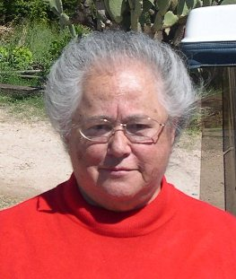
One Can A Week

Personal Commitment
To Community Service


Peter G. Norback
(520) 248-3694
One Can A Week

Personal Commitment
To Community Service
Barbara Farragut
(520) 982-8824
One Can A Week

Personal Commitment
To Community Service
Peter G. Norback
(520) 248-3694
One Can A Week

Personal Commitment
To Community Service
Peter G. Norback
(520) 248-3694
One Can A Week

Personal Commitment
To Community Service
Peter G. Norback
(520) 248-3694

PHOTO

PHOTO

PHOTO

